Bryan Clifton and Dima Koyfman
MSOD Pi Prime - 617

ATTRACTIVENESS
Homes are filled with mundane but important technologies we use every day. These items exist to serve a specific function. Over the years, little has change in their design and purpose.
This was the motivation behind Nest Labs first step into the Internet of Things. They envisioned a new type of home. A “conscious home” connected by smart devices that enable you to live a better life (Wohlsen, 2014).
In 2010, Nest Labs founders Anthony Fadell and Matt Rogers approached investors at the venture capital firm Kleiner Perkins Caufield & Byers about their idea for a “smart” thermostat. While skeptical at first about the marketability of a new type of thermostat, a single statement made the investors realize the potential in front of them.
Fadell said, “After the thermostat, we're going to reimagine every unloved product in people's lives.” "When I saw that, I looked around my office at all of the beige plastic devices that had populated my life and were trying to hide from view because they were so ugly and cheap," one of the potential investors recalled. "At that point I had to be in (Primack, 2014)."
Investors like these poured millions into Nest over the coming years. In January of 2014, Google acquired Nest Labs for $3.2 billion. The price tag for Nest Labs is almost double the amount Google paid for YouTube and $100 million more than it paid for ad-tech firm DoubleClick. Nest is expected to be a cornerstone of the company's future beyond advertising (Peterson, 2014).
In a recent 10-Q filing, Google states, “The acquisition is expected to enhance Google's suite of products and services and allow Nest to continue to innovate upon devices in the home, making them more useful, intuitive, and thoughtful, and to reach more users in more countries (Google, Inc, 2014, pp. 19–20).”
While some speculated about the price Google paid for Nest, others are looking at the larger picture which is the emerging industry based on an Internet of Things. Creating the hardware is one opportunity, but owning the network through which the things are connected could be more advantageous in the long run. The interconnectedness of the hardware holds the true value. With devices talking to each other, a new picture emerges revealing how humans interact with the world around them. It uses this knowledge to anticipate our next steps (Wohlsen, 2014).
Now imagine that infrastructure not just connected, but connected by Google. With its product and design expertise, Nest provides Google an ideal platform for stretching the power of its own intelligent machines beyond the web and into the internet of things (Wohlsen, 2014).
Companies from the technology sector to historical appliance manufactures see the opportunity a network of connected devices brings to the marketplace. In many ways, this is a new frontier with endless opportunities. Apple and Google would love to be the company that cashes in on, or at least controls, whatever turns out to be IoT equivalent of a modern automobile, with its hundreds of integrated chips and battery-powered activators (Elmer-DeWitt, 2014).
From an industry vantage point, these innovations could revolutionize how we live, how we consume energy, and how we plan for the future. Devices such as refrigerators, dishwashers, washers and dryers, water heaters, lighting controls, and many other household items are prime for a redesign. If Google can achieve the same level of energy reduction in these applications as it did with a thermostat, utilities could be facing an additional 10 to 20 percent reduction in load. Add to this mix the commercialization of electric vehicles, distributed generation and fuel cells, and Google just bought itself a revenue stream destined for growth well into the future (Bodell, 2014).
While the future for IoT is bright, it does face challenges. The largest challenge is substitute products. Almost every product that exists in IoT also exists as an analog device that functions and does the intended job. While it does not connect to the internet, it serves the purpose it is designed to do. Creating the motivation for someone to invest in a more expensive device will require new purchases. The substitute products are the ones already in the homes of consumers.
While Nest, Google, and Apple are experiencing first mover advantage, others like Philips and new startups are quickly moving into the space. Additional entries can fight for market share, but they will have an uphill battle to displace giants of the technology world.
This is a new industry that merges aspects of traditional technology and manufacturing. As with most new industries the financial returns have the potential to be enormous, but this comes with a higher risk level than established arenas. For the risk taker and technology advocate, this is an opportunity that only comes once in a lifetime. Missing a chance to invest in this industry could be the equivalent of missing the technology boom of the 1990’s or automotive growth of the mid 20th century.
The investment opportunities for this industry are astounding. Large companies are pouring resources into new R&D to create additional products primed for the marketplace.
This is only the beginning of an industry that is destined to change how we live. Nest says they’ve sold somewhere around 1 million thermostats, telling Forbes recently the product is in almost 1% of U.S. households (Rogowsky, 2014). This leaves millions of homes in America, not to mention globally, as prime customers for a coming digital age that reaches from your pocket to your appliances.
We are already experiencing technology that allows your thermostat to communicates with your Mercedes, Whirlpool washer, or Jawbone fitness tracker (‘Works with Nest.’, n.d.). While these may seem trivial to some, the opportunities this provides will only deepen with additional acceptance in the economy.
Nest is but one example of a company that is revolutionizing how we interact with our environment. This emerging industry will change the way we live.

POSITION
"The question remains ... whether the new thermostats will be used in a way that actually helps customers use less energy," the study said. "While it's too soon [to] pass judgment on the far end of the communications path, we can say with some certainty that these new standards will not affect energy savings if customers don't like or can't figure out how to use the new thermostats."
Nest’s competitive position in the industry is in three categories:

1) First Mover
2) Partnerships
3) User Experience

First Mover - Tony Fadell, former Engineering VP at Apple began working on what later became the Nest Thermostat after building a vacation home and being unhappy with all the thermostat options available. Fadell partnered with Matt Rogers and Nest became a company in 2010, releasing the Nest Thermostat as it’s first product in 2011. Nest became the first mover in the industry with competitors starting to emerge only in the past two years. Honeywell, the current top vendor in thermostats, has been in the thermostat business for 50 years. In just three years, Nest has vaulted into second place (Hill, 2013). Honeywell released their competition, the Wi-Fi Smart Thermostat on April 9th, 2013. By that time, Nest was already selling 40,000 to 50,000 units per month (Fehrenbacher, 2013). Being “stuck in the middle” looks to not be a concern for Nest because it is projected to increase monthly unit sales to 250,000 per month in 2015 (1). By being the first mover, Nest will have an advantage with reputation, innovation, and moving the learning curve of the customer base (Duhaime, 2011).

Partnerships - Nest has built very valuable relationships internally and externally since it’s debut. Internally, the connection with Tony Fadell has given the company a significant advantage in terms of reputation. As one of the “Fathers”of the iPod, consumers and critics had high expectations of Fadell’s first major endeavor after leaving Apple (Krazit, 2008). The association with such a figure in technology, innovation, and design immediately separated Nest from it’s competitors. Fortune Magazine ranked Google the 2nd most admired company in 2012 (Fortune, 2012). In addition to the customer base and brand loyalty that comes from a partnership with Google, Nest now has direct access to some of the most talented minds in the tech world. Google also provides financial might, global reach, infrastructure (servers, etc), analytics with software intelligence, sales and distribution network. Externally, Nest has distribution relationships with Amazon, Best Buy and Apple stores. The Nest is the #1 Best Seller in the Home Programmable Thermostat section of Amazon and the only programmable thermostat sold in Apple Stores. In terms of Product Standards, Nest is working with ENERGY STAR to define industry standards for home automation devices. In regards to utility service providers, Nest has natural allies helping reduce utilities consumption (gas and electricity used for heating). For example, Nest has a partnership with Reliant, a Texas-based retail energy provider to offer a Nest thermostat to customers who sign on for a two-year contract (Volpe, 2012). Nest can reach 1.5M customers of Reliant this way. In terms of Government, Nest is partnering to understand trends and ways to reduce energy us. Government policies could be a catalyst in adoption of smart thermostats (2).

User Experience - In terms of Nest’s value proposition, an intuitive, simple user-experience is a primary focus. Features and Ease of Use combine to make up 32% of how consumers buy smart thermostats (Tugrul, 2010). Nest also has a proven track record of creating Savings on heating bills and is priced competitively. Savings and Cost make up 40% of the reason people buy smart thermostats. The nest is the only thermostat the learns over time. Based on the initial settings and how you use the Nest, the device will adapt and customize to your behaviors. Additionally, it easily installs, provides energy-saving tips and is easily controllable using wi-fi enables devices such as computers, smart phones, or tablets (3). The Nest is the highest overall rated Smart Thermostat and is ranked significantly higher in Ease of Use compared to it’s competitors. (Ferris, 2014)

CITATIONS
Carr, A. (2013, January 30). Tony Fadell’s Nest Thermostat Company Hits $800 Million Valuation. Retrieved 27 September 2014, from http://www.fastcompany.com/3005231/tony-fadells-nest-thermostat-company-hits-800-million-valuation
Fehrenbacher, K. (2013, January 29). Exclusive: Nest has raised another $80M, now shipping 40K+ thermostats a month. Retrieved 27 September 2014, from https://gigaom.com/2013/01/29/exclusive-nest-has-raised-another-80m-now-shipping-40k-thermostats-a-month/
Google, Inc. (2014). FORM 10-Q.
Holmes, D. (2012, June 26). Why Nest Founders Tony Fadell And Matt Rogers Left Apple To Build A Thermostat. Retrieved 27 September 2014, from http://www.fastcompany.com/1841312/why-nest-founders-tony-fadell-and-matt-rogers-left-apple-build-thermostat
Rogowsky, M. (2014, January 14). 5 Reasons Nest Sold To Google.Forbes. Forbes. Retrieved from http://www.forbes.com/sites/markrogowsky/2014/01/14/5-reasons-nest-sold-to-google/
Wohlsen, M. (2014, January 14). What Google Really Gets Out of Buying Nest for $3.2 Billion. Retrieved 27 September 2014, from http://www.wired.com/2014/01/googles-3-billion-nest-buy-finally-make-internet-things-real-us/
Works with Nest. (n.d.). Retrieved 27 September 2014, from https://nest.com/works-with-nest/#previous
PETERSON, T. (2014). GOOGLE'S $3.2B NEST BUY IS A BET ON REVENUE BEYOND ADVERTISING. Advertising Age, 85(2), 11.
Primack, D. (2014). Sales pitch: What Nest said to get its original investment. Fortune.Com, 1.
Elmer-DeWitt, P. (2014). Apple and Google angle for control of the Internet of Things. Fortune.Com, 1.
Elmer-DeWitt, P. (2014). Why Google, not Apple, bought Tony Fadell's Nest Labs. Fortune.Com, 1.
Bodell, T. (2014). Why Google Bought Nest for $3.2 Billion. Electric Light & Power, 92(1), 12.
Ferris, D. (2014, April 25). In user test, Nest thermostat -- and its 'smart' competitors -- disappoints. Retrieved September 28, 2014.
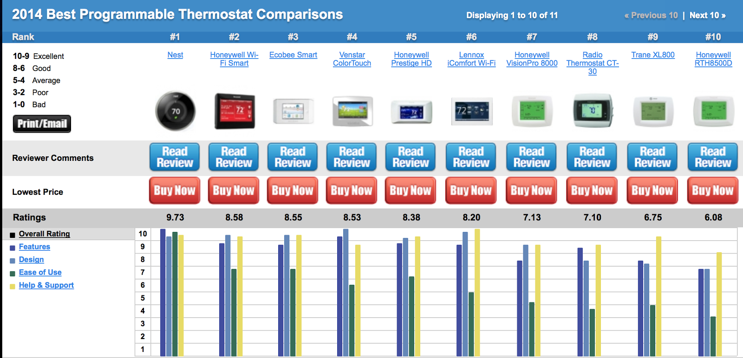
Carlsen, John. "Programmable Thermostats Review." TopTenREVIEWS. TopTenREVIEWS, 27 Mar. 2014. Web. 27 Sept. 2014
Hill, J. (2013, November 14). Honeywell Leads Smart Thermostat Leaderboard. Retrieved September 28, 2014.
Krazit, T. (2008, November 3). Report: Tony Fadell, iPod chief, to leave Apple post - CNET. Retrieved September 28, 2014.
Google (2014, January 13). Google to Acquire Nest. Retrieved September 28, 2014
Fortune. (2012, March 19). Worldís Most Admired Companies: Google ranks No. 2. Retrieved September 28, 2014.
Volpe, J. (2012, June 25). Nest partners with Texas utility, offers intelligent thermostat to energy-conscious households. Retrieved September 28, 2014.
http://www.humanities360.com/index.php/how-the-1970s-oil-crisis-affected-the-us-economy-2-11702/ (2)
Fehrenbacher, K. (2013, January 13). Exclusive: Nest has raised another $80M, now shipping 40K thermostats a month. Retrieved September 28, 2014.
Duhaime, I., Stimpert, J., & Chesley, J. (2011). Strategic thinking: Today's business imperative. New York: Routledge.
Breaking Down The Valuation For Nest's $3.2 Billion Purchase Price. (2014, January 14). Retrieved September 28, 2014. (1)
Tugrul U. Daim, Ibrahim Iskin, (2010), “Smart thermostats: are we ready?”, International Journal of Energy Sector Management, Vol..4 Iss:2
https://nest.com (3)

