Team Gravity: OCAI Pi Prime Culture Report
Bryan Clifton, Michael Jonckheere, Dima Koyfman, Heather McCabe,
Pam Miller, Sarah Rowe, Ruthie Weller
Pepperdine University

The current culture of Pi Prime as assessed by the Gravity Learning Group is predominantly a clan culture. Gravity identified that similar efforts, common direction and clarity of culture exists around those features of the culture that characterize clan cultures.
The strength of Pi Prime’s current clan culture indicates that efforts to change the culture would need to be more numerous and profound. With the desired culture closely mirroring the current state of Pi Prime’s culture, significant adjustments are unlikely to be necessary. As indicated in the chart below, Gravity would prefer a slight increase in adhocracy and slight decrease in hierarchy to occur. Additionally, though a high degree of cultural alignment exists, opportunities to further congruency are present.

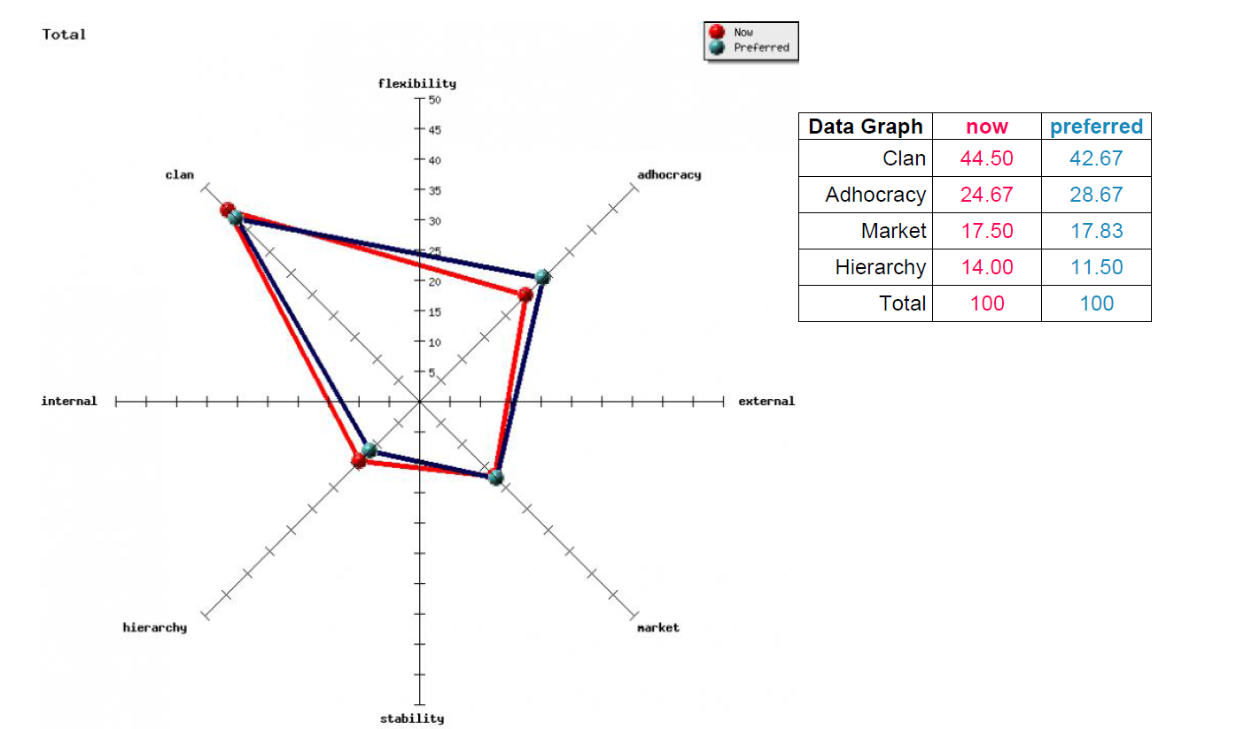

Opportunities & Issues
A high level of cultural congruency exists across the board both now and preferred, with clan and adhocracy culture having the highest scores followed by market and hierarchy culture. Such congruency lends itself to a unified focus on values and assumptions within the learning group/cohort and lower levels of disconnect and other obstacles (Cameron & Quinn, 2011). The result of this congruency can be higher levels of performance overall.
In all areas, the highest scores, both now and preferred, are found in the clan culture. This represents a strong focus on people, teamwork and collaboration within the organization that can lend itself well to high performance in a group setting such as the cohort and learning group (Cameron & Quinn, 2011). When coupled with moderately strong adhocracy scores, this can create a culture in which innovation and creativity are supported and stimulated by collaboration within the cohort.
However, too much emphasis on a clan culture could also limit the expression of entrepreneurial thought at an individual level in our cohort. In the majority of areas, the preferred level of adhocracy was slightly higher than the current state. If adhocracy was to increase to this preferred level, a greater balance could be struck between group collaboration and creativity/innovation. Increasing the market culture in the areas of strategic emphasis and criteria of success could also add more balance to the culture, as suggested in the preferred levels in these areas, by placing more emphasis on productivity and results-oriented projects amid collaboration. This could increase the effectiveness of projects within the adhocracy and clan culture by giving more structure to initiatives and adding strategic analysis to the measurement of success for both individual and group projects.

Proposed Interventions
Our learning group has identified an intervention for three levels of the cohort: Community level, Learning Group level and the Individual level. The first intervention is an activity for the cohort to build upon the desired and already strong clan culture. The cohort can complete and share the outcome of the Trust Principles Inventory exercise, from The Four Trust Principles by Gloria E. Bader, Ed. D. 2002. The intent of this activity is to promote increased trust among the community.
The second intervention will address the Learning Group level. Team Gravity will define a conflict resolution strategy for when conflict arises in the group, particularly when working abroad. From the formation of our Learning Group, we have had relative ease working together. We value the quality of our group, and the relationships that characterize our team. By having a conflict resolution strategy in place, this will help protect and potentially strengthen the relationships and culture of our learning group, helping to support the clan and adhocracy culture in particular.
The third intervention is for the Individual level. Each person in the cohort can complete the Management Skills Assessment Instrument in Appendix B of Diagnosing & Changing Organizational Culture, Cameron & Quinn (2011). Then each person can review their results to enhance self-awareness and identify one thing they can do to strengthen adhocracy.
The OCAI Team Gravity Pi Prime results overall showed a minor gap between our current and desired state. The selected interventions will capitalize on the culture we have already created and strengthen the areas we can and desire to grow.
References
Cameron, K.S. & Robert E. Quinn (2011). Diagnosing and Changing Organizational Culture: Based on the Competing Values Framework. New York: John Wiley.

